*Laboratory Report*

**INTERNET TECHNOLOGIES LAB.**

**CAP5004L**

**School of Engineering**

**Department of Computer Science and Engineering**

|  |  |
| --- | --- |
| **Submitted By** | |
| **Student Name** | Amit |
| **Roll Number** | 180020307001 |
| **Section/Group** |  |
| **Department** | Computer Science and Engineering |
| **Session/Semester** | 2020-21/ Odd Semester |
| **Submitted To** | |
| **Faculty Name** | Ms. Manka Sharma |



**GD Goenka University**

Sohna road, Gurugram, Haryana

**Table of Content**

|  |  |  |  |
| --- | --- | --- | --- |
| Sl No | Date | Aim of the Experiment | Signature/date |
|  |  |  |  |
|  |  |  |  |
|  |  |  |  |
|  |  |  |  |
|  |  |  |  |
|  |  |  |  |
|  |  |  |  |
|  |  |  |  |
|  |  |  |  |
|  |  |  |  |

|  |  |  |
| --- | --- | --- |
| **Experiment No-5.1** |  | **Date:** |

**Aim of the Experiment:**

Write a program in javascript to accept two equal sized string arrays from the user and concatenate their corresponding elements. Also, display their length.

**Source Code - index.html**

<!DOCTYPE html>

<html lang="en">

<head>

<meta charset="UTF-8">

<meta name="viewport" content="width=device-width, initial-scale=1.0">

<title>JS Experiments</title>

</head>

<body>

<div>

x: <p id="x" style="display: inline-block;"></p> <br>

y: <p id="y" style="display: inline-block;"></p> <br>

sum: <p id="sum" style="display: inline-block;"></p>

</div>

<script>

var x = [],

y = [],

length = prompt("Length of arrays: "),

sum = [],

x_val = '',

y_val = '',

sum_val = '';

for (var i = 0; i < length; i++){

x.push(parseInt(prompt("Value of x" + (i + 1))));

x_val += x[i] + ' ';

y.push(parseInt(prompt("Value of y" + (i+1))));

y_val += y[i] + ' ';

sum.push(x[i] + y[i]);

sum_val += sum[i] + ' ';

}

document.getElementById('x').innerText = x_val;

document.getElementById('y').innerText = y_val;

document.getElementById('sum').innerText = sum_val;

</script>

</body>

</html>

**Output**

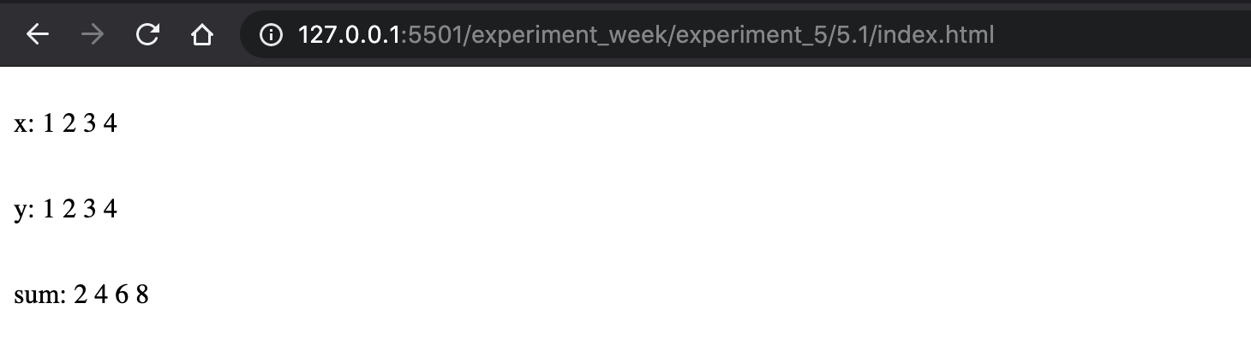

|  |  |  |
| --- | --- | --- |
| **Experiment No-5.2** |  | **Date:** |

**Aim of the Experiment:**

Write a program in javascript to create a mixed array and display all its elements.

**Source Code**

<!DOCTYPE html>

<html lang="en">

<head>

<meta charset="UTF-8">

<meta name="viewport" content="width=device-width, initial-scale=1.0">

<title>JS Experiments</title>

</head>

<body>

<div>

x: <p id="x" style="display: inline-block;"></p>

</div>

<script>

var x = [1, 2.2, "Amit"];

document.getElementById('x').innerText = x;

</script>

</body>

</html>

**Output**

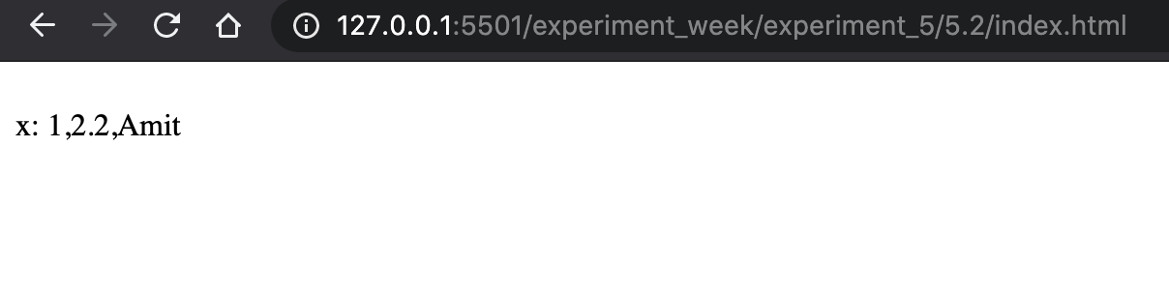

|  |  |  |
| --- | --- | --- |
| **Experiment No-5.3** |  | **Date:** |

**Aim of the Experiment:**

Write a program in Javascript to accept 5 element array from the user and sort it.

**Source Code - index.html**

<!DOCTYPE html>

<html lang="en">

<head>

<meta charset="UTF-8">

<meta name="viewport" content="width=device-width, initial-scale=1.0">

<title>JS Experiments</title>

</head>

<body>

<div>

x: <p id="x" style="display: inline-block;"></p>

</div>

<script>

var x = [];

for (var i = 0; i < 5; i++) {

x.push(prompt("Value of x" + (i+1)));

}

document.getElementById('x').innerText = x.sort();

</script>

</body>

</html>

**Output**

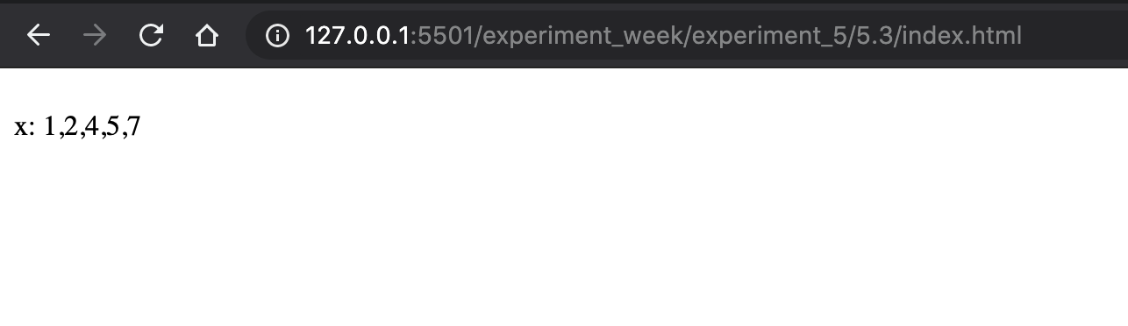

|  |  |  |
| --- | --- | --- |
| **Experiment No-5.4** |  | **Date:** |

**Aim of the Experiment:**

Create an array of 10 elements and show: Push, Pop, Shift, Unshift, Change the element, sort, splice, slice, toString, concatenate with values.

**Source Code**

<!DOCTYPE html>

<html lang="en">

<head>

<meta charset="UTF-8">

<meta name="viewport" content="width=device-width, initial-scale=1.0">

<title>JS Experiments</title>

</head>

<body>

<div>

x_push: <p id="x_push" style="display: inline-block;"></p> <br>

x_pop: <p id="x_pop" style="display: inline-block;"></p> <br>

x_shift: <p id="x_shift" style="display: inline-block;"></p> <br>

x_unshift: <p id="x_unshift" style="display: inline-block;"></p> <br>

x_change: <p id="x_change" style="display: inline-block;"></p> <br>

x_sort: <p id="x_sort" style="display: inline-block;"></p> <br>

x_splice: <p id="x_splice" style="display: inline-block;"></p> <br>

x_slice: <p id="x_slice" style="display: inline-block;"></p> <br>

x_toString: <p id="x_toString" style="display: inline-block;"></p> <br>

x_concat: <p id="x_concat" style="display: inline-block;"></p> <br>

</div>

<script>

var x = [10,2,3,4,5,60,7,8,9,10];

// PUSH

x.push(11);

document.getElementById('x_push').innerText = x;

// POP

x.pop();

document.getElementById('x_pop').innerText = x;

// SHIFT

x.shift();

document.getElementById('x_shift').innerText = x;

// UNSHIFT

x.unshift();

document.getElementById('x_unshift').innerText = x;

// SORT

document.getElementById('x_sort').innerText = x.sort(function(a, b){return a - b});

// CHANGE ELEMENT

x[0] = (12);

document.getElementById('x_change').innerText = x;

// SPLICE

x.splice(1, 0, 13);

document.getElementById('x_splice').innerText = x;

// SLICE;

document.getElementById('x_slice').innerText = x.slice(2);

// toString;

document.getElementById('x_toString').innerText = x.toString();

// CONCATINATION;

document.getElementById('x_concat').innerText = x.concat([12,13,14]);

</script>

</body>

</html>

**Output**